Practical 6: Inter process communication

**Introduction**

In this lab we will attempt to do the following:

1. Do a demo on inter thread communication
2. Do a demo on Socket communication
3. Do a demo on RabbitMQ communication

install RabbitMQ, create a RabbitMQ publisher and a subscriber

**2. Do an inter-threading example in class**

Follow instructions here:

<http://www.tutorialspoint.com/java/java_multithreading.htm>

**3. Do a Socket communication example in class**

Follow instructions here:  
<http://www.rabbitmq.com/install-windows.html>

**4. Producer/Consumer example via RabbitMQ**

**4.1. Install Erlang and RabbitMQ**

<http://www.rabbitmq.com/install-windows.html>

<http://www.rabbitmq.com/tutorials/tutorial-one-java.html>

**4.2. Create producer**

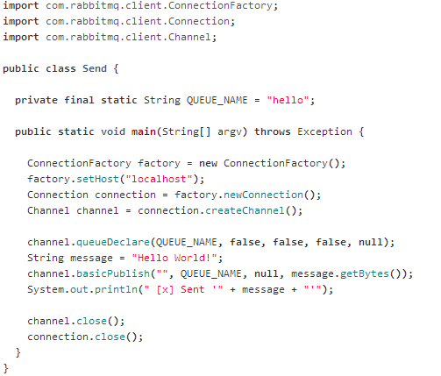

**4.3. Create consumer**

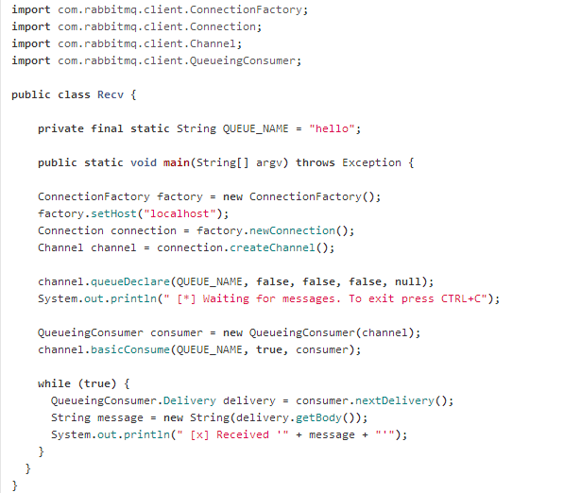

**4.4. Run application**

Attempt to run the application where a message should be sent to consumer from producer via a broker.

**5. For submission**

Submit a written report on this lab to [billy.stack@staff.ittralee.ie](mailto:billy.stack@staff.ittralee.ie) that explains what you learned in relation to:

* Inter-threading communication within the one process
* Inter-process communication via Sockets
* Inter-process communication via RabbitMQ broker